OLBIA: 10 MOST BEAUTIFUL BEACHES FROM TAVOLARA TO SAN TEODORO

Best beaches close from Olbia to San Teodoro, passing through Tavolara Island

1. [Home](https://civitavecchia.portmobility.it/it)
2. [To see](https://civitavecchia.portmobility.it/it)
3. [Sardinia and Sicily](https://civitavecchia.portmobility.it/it)

**0**

SHARES

* [](http://www.facebook.com/sharer.php?u=http%3A%2F%2Fcivitavecchia.portmobility.it%2Fen%2Folbia-10-most-beautiful-beaches-tavolara-san-teodoro&display=popup)
* [](https://twitter.com/intent/tweet?original_referer=http%3A%2F%2Fcivitavecchia.portmobility.it%2Fen%2Folbia-10-most-beautiful-beaches-tavolara-san-teodoro&text=%40Portmobilityweb+-+Olbia%3A+10+most+beautiful+beaches+from+Tavolara+to+San+Teodoro&tw_p=tweetbutton&url=http%3A%2F%2Fcivitavecchia.portmobility.it%2Fen%2Folbia-10-most-beautiful-beaches-tavolara-san-teodoro)
* [](https://plus.google.com/share?url=http%3A%2F%2Fcivitavecchia.portmobility.it%2Fen%2Folbia-10-most-beautiful-beaches-tavolara-san-teodoro)

In this article we'll take you to discover the**10 most beautiful beaches south to Olbia**, passing through the island of **Tavolara** and arriving until the city of **San Teodoro**.

A stretch of coast full of **surprises and wonderful beaches**, ideal if you want to strike a balance between wordly and relaxing life!

If in the meanwhile you are wondering when the **ferries to Olbia** depart, take a look to this article!

[**CIVITAVECCHIA-OLBIA: FERRIES 2016**](http://civitavecchia.portmobility.it/en/civitavecchia-olbia-ferry-timetables-2016)

[**Olbia, from Tavolara to San Teodoro: 10 dream beaches** | 10 photos **Go to gallery**](https://civitavecchia.portmobility.it/en/slideshow/olbia-tavolara-san-teodoro-10-dream-beaches/0?ref=1)

**1. SALINE BEACH**

Just a few minutes from Olbia, the **Saline** is **the first beach that you can find** along the south coast and also the ideal destination for a last dip before coming back from vacation.

The beach, rather long, consists of **reddish coarse sand**and ideal for **pleasant walks on the waterline.**The seabed, due to the strong backwash, degrades quickly toward 2 meters; it is not by chance that the beach is**very popular among lovers of surf and sailing.**

**To reach it**you have to walk about 8 km along the road S.S. 125 in direction to Siniscola, arrive at a long straight road at the center of which turn left and after about another kilometer you come to a **large free parking space.** Here you can leave your car and walk through a **wooden pier** that connects the beach...and you have arrived!

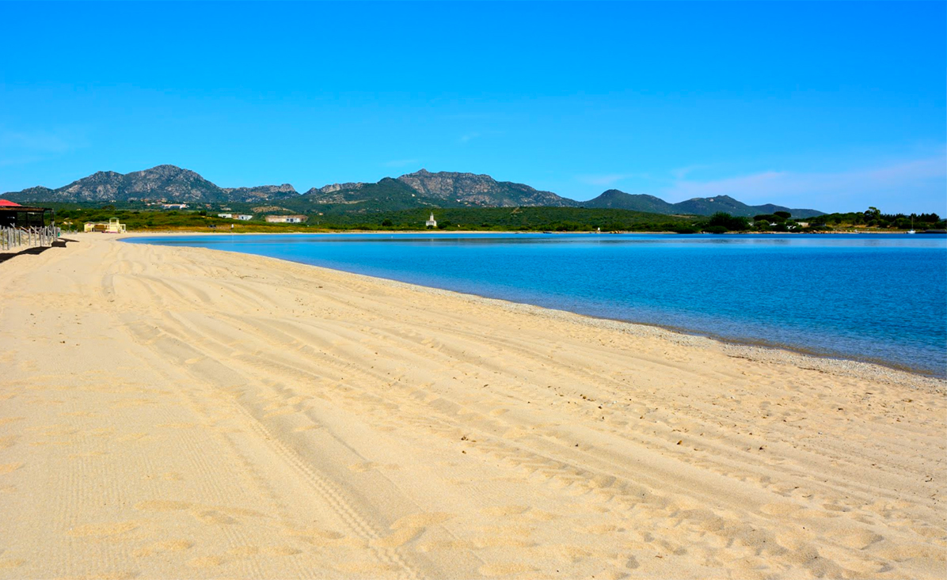

Saline Beach - Olbia

**2. DOTTORE BEACH**

**The Dottore beach** is a small corner of paradise surrounded by greenery and framed by beautiful granite rocks.

The sand strand is distinguished by a **white very thin sand alternated with small colored pebbles**and a wonderful **sea of crystalline turquoise color,** ideal for snorkelers and scuba divers.

To reach it, also in this case you have to take the highway (SS125) direction Siniscola until Murta Maria. From there turn left on Viale Porto Istana until junction with Via Punzutu. Once you reach an open space with a parking lot you will need to walk for about 15 minutes and you have arrived!

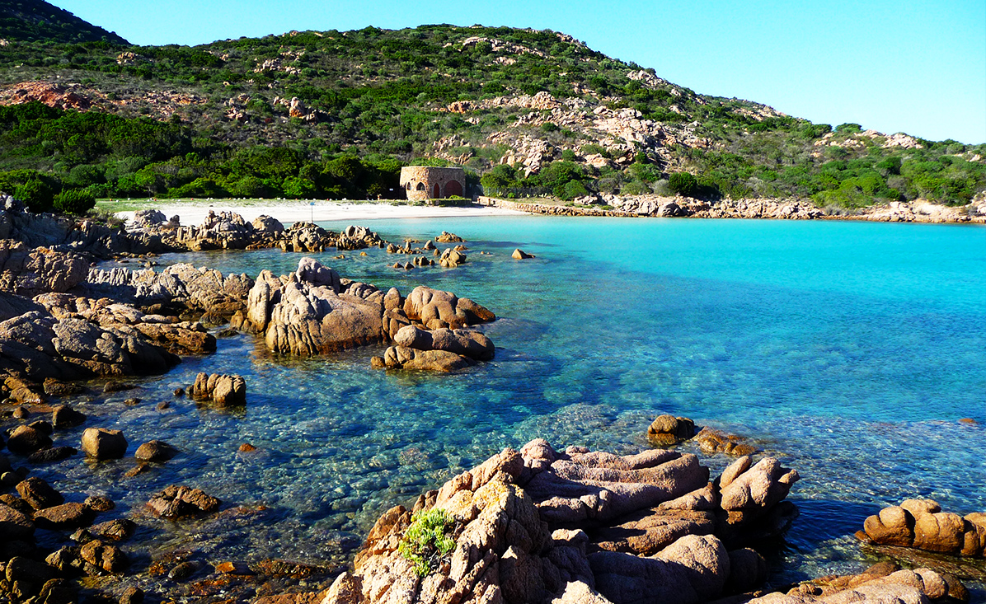

Dottore Beach - Olbia

**3. PORTO ISTANA BEACH**

To reach the beautiful **beach of Porto Istana** apply the same indications given for the beach of Dottore, with the only exception that once you take Viale Porto Istana you must continue until a dirt parking space; a few minutes walk and you will find yourself in front of the sea.

The beach, rather large, is **interspersed with small rocky bands**and it is constituted by **fine, white sand** that slopes gently in the emerald waters.

Located opposite **Tavolara Island**, that **reminds a little bit of a gigantic brontosauro** that emerges from the waters, the beach of Porto Istana offers **many services** and activities including windsurfing, canoeing, jet-ski, sailing, surfing and much more.

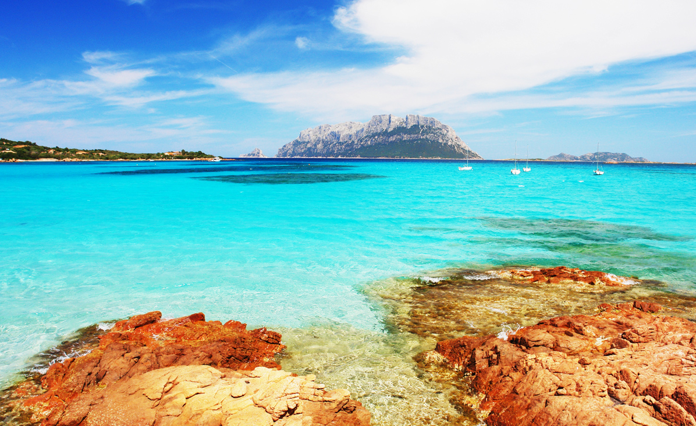

Porto Istana Beach - Olbia

**4. SPALMATORE BEACH ON THE TAVOLARA ISLAND**

To**reach the Tavolara Island**, you can take a **ferry from Porto S. Paolo**, located about 16 km from Olbia and accessible via Strada Statale 125 (SS125).

The island presents itself as a **mountain of limestone and granite more than 500 meters high** from the sea level only accessible to the lovers of free climbing. The single strip of low land is represented by the beach known as**Spalmatore di Terra**, where you will also find a small port, several restaurants and a few buildings.

On this enchanting strip of sand grow**sea daffodil**while the rock is covered with bushes of **juniper, rosemary and lentisk.**

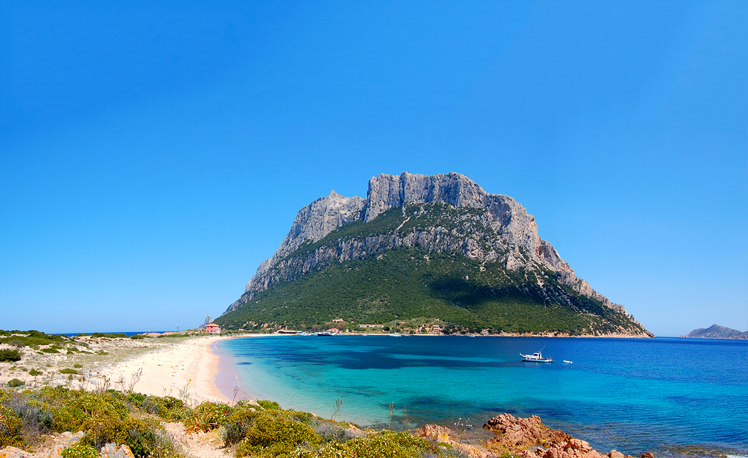

Spalmatore Beach on the Tavolara Island

**5. PUNTA MOLARA BEACH**

Always along the state road SS125, at the height of Monte Petrosu, you can turn left in Via Molara and thus reach the **little bay of Punta Molara**.

From the beach, composed of white sand alternated with cliff, you can enjoy the **beautiful panorama with the island of Molara on the background.**

In addition, for all nature lovers, the promontory of Punta Molara also hosts the **gardens of the Mediterranean maquis**, a didactic park of 50 hectares, which houses a large amount of botanical species through evocative paths immersed in the colors and scents of the Mediterranean maquis.

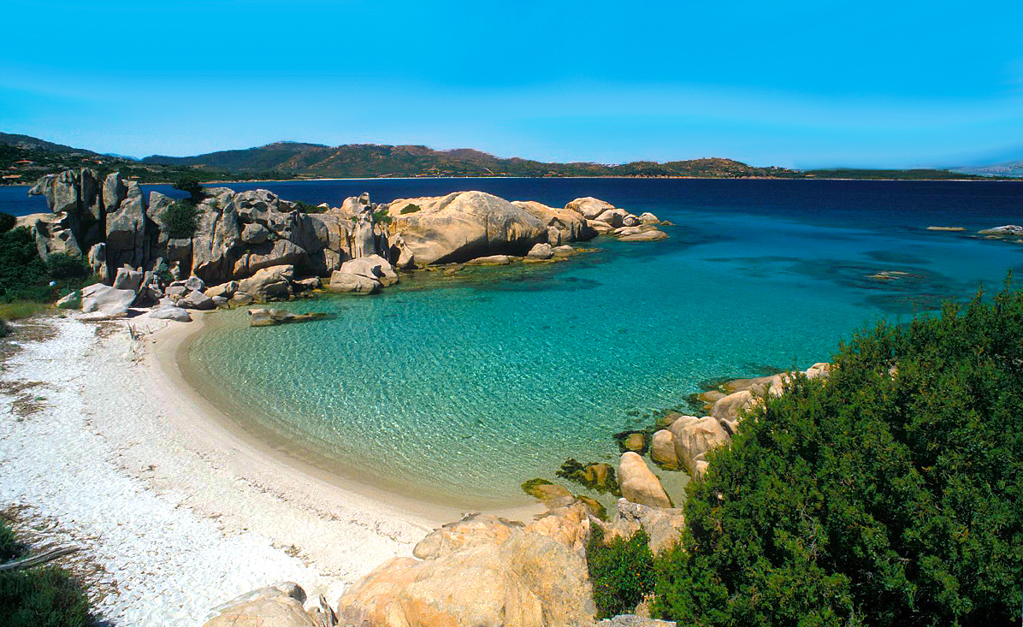

Punta Molara Beach

**6. SALINA BAMBA BEACH (PUNTA CODA CAVALLO)**

**Salina Bamba Beach** is located between Cala Brandinchi and Baia Salinedda in**Capo Coda Cavallo**, inside of the town of San Teodoro.

Behind the beach, characterised by shallow and sandy waters, you can admire the **salted water basin** to which it owes its name, populated by numerous specimens of marine birds.

**To reach it**you need to take the Strada Statale 125 for Siniscola, go straight on until Lutturai to turn then toward Capo Coda di Cavallo. Here you can park your car and walk along a dirt road for about 50 meters following the indications to the beach.

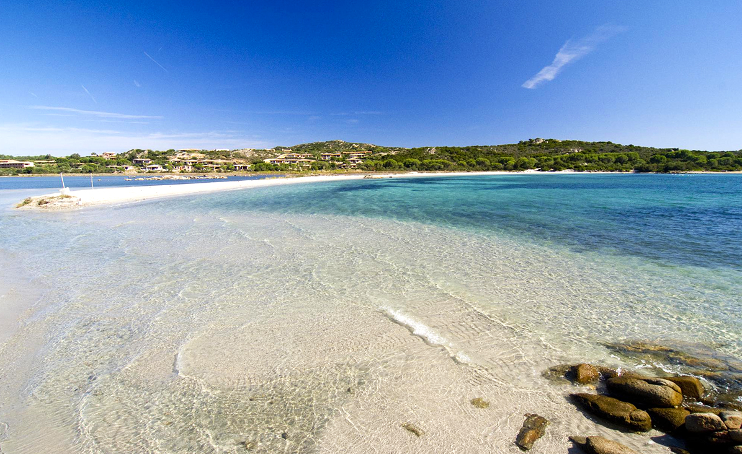

Salina Bamba Beach - San Teodoro

**7. CALA BRANDINCHI (SAN TEODORO)**

Continuing along the coast meets **Cala Brandinchi** that with its crystal clear water and the shallow waters of white sand will remind you of the **Caribbean**!

The beach is equipped with a **parking** fee and **many services**. It is also possible to rent beach umbrellas, deck chairs, shoe and boats.

Especially **in high season the beach is very busy**so we advise you to arrive early in the morning or bring with you the right equipment; it is possible that once the beach are no longer remained umbrellas free!

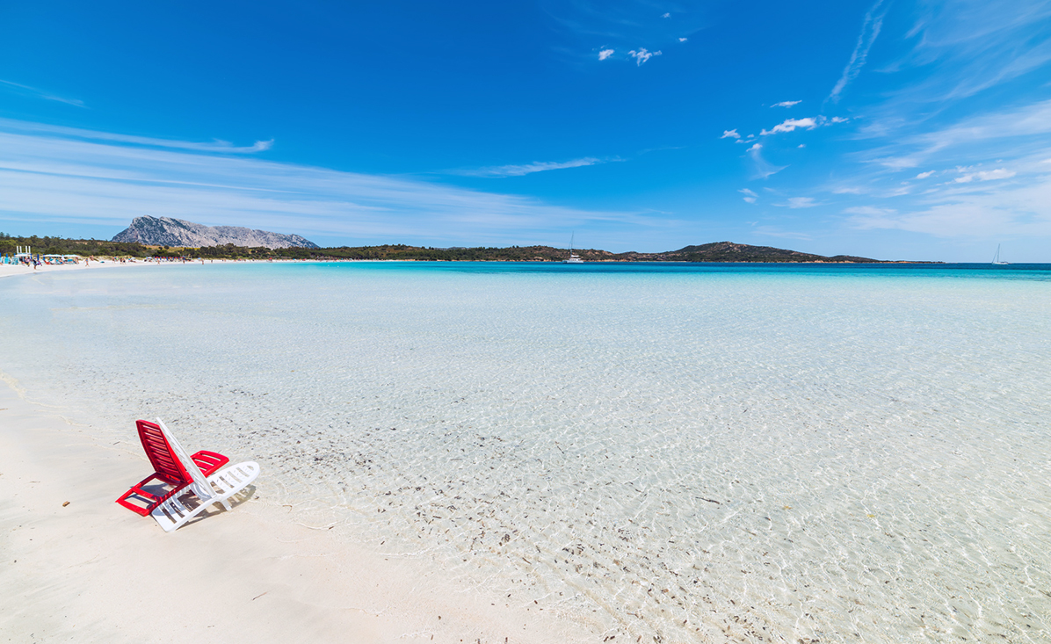

Cala Brandinchi - San Teodoro

**8. LU IMPOSTU BEACH (SAN TEODORO)**

Continuing toward south, before encountering the **promontory of Puntaldia** it is really worth visiting the wonderful **beach of Lu Impostu.** The name which means "place of departure", testifies the fact that very probably in the past the beach of Lu Impostu was used for trade and shipment of goods while today it is a **beautiful seaside resort**, very loved by those in search of beaches more intimate.

The **vegetation is very rich**: milt thistle, wild lilies and mimosas entire surrounding the beach, where it is possible to find**tourist services of every kind**of food and beverage outlets, rental of beach umbrellas and boats up to scuba diving courses.

The sand, clear thin and bathed by a blue sea with shallow water and sandy, **ideal for those traveling with kids.**

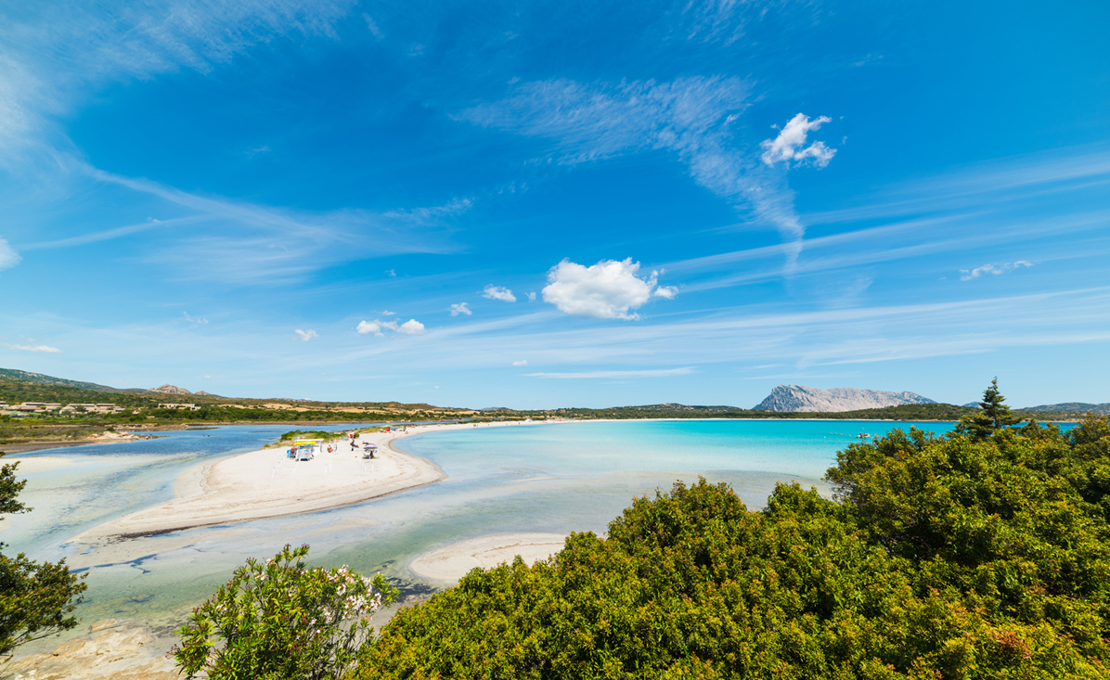

Lu Impostu Beach - San Teodoro

**9. LA CINTA BEACH (SAN TEODORO)**

**La Cinta** is one of the most famous beaches in the whole of Sardinia and one of the attractions the most sought after in **San Teodoro**.

**Equipped with every kind of services**, including a tourist information point, the beach is located on a narrow tongue of land around 5 km long, recognizable for its **white sand and the water turquoise color.**

Behind the **pond of San Teodoro** is a very interesting destination for all nature lovers. In fact it is possible to find splendid specimens of **pink flamingos** but also coots, little terns, red herons and mallards who live undisturbed in these waters.

From San Teodoro you can also reach it on foot, while **from Olbia you should follow the State Road 125 direction San Teodoro** for about 24 km, turn left at the height of the crossroad main entrance to the village of San Teodoro, after 850 meters pass a bridge and immediately after turn up to the parking of the beach.

La Cinta is **one of the most popular beaches of San Teodoro**, therefore, if you do not love the mob, we advise you to arrive early in the morning or to visit in the low season months as June or September, during which does not lose even a bit of its charm!

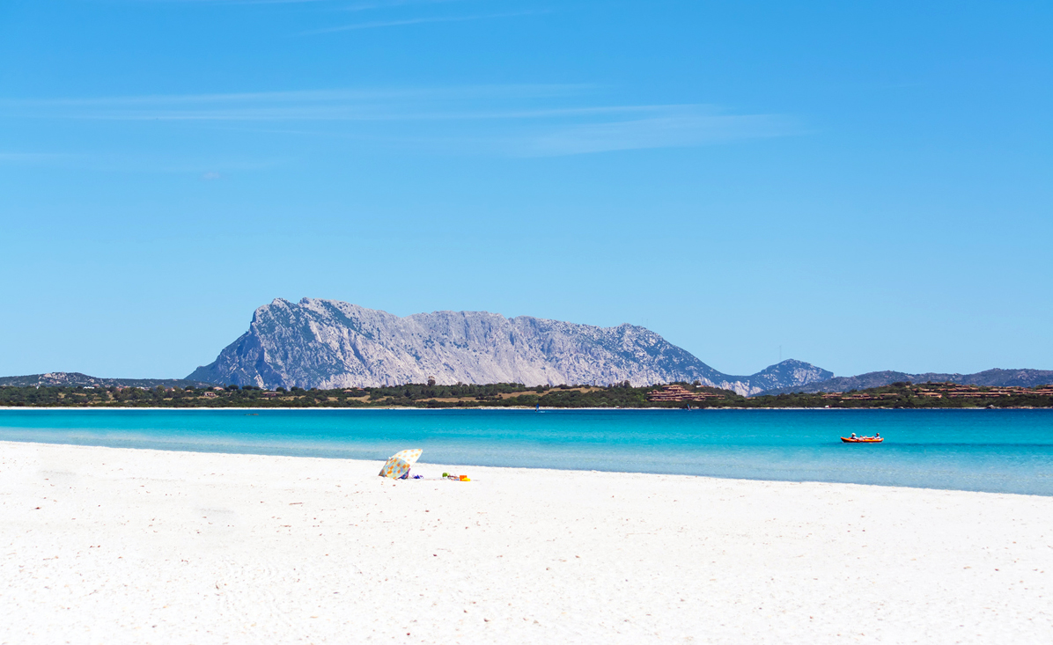

La Cinta Beach - San Teodoro

**10. ISULEDDA BEACH (SAN TEODORO)**

We conclude our exploration of the coast **south to Olbia** with the enchanting**beach of Isuledda**, in the municipality of **San Teodoro**.

It is about 385 meters long, it is characterized by a beach of**fine white sand**and it has **shallow waters**, perfect for the bathroom of children. Its **crystalline and clear waters**, instead, reflect the stupendous colors ranging from emerald green to turquoise to clear blue.

The Isuledda Beach puts at the disposal of its bathers a **wide range of services**: parking lot, refreshment points, umbrellas, deck chairs, canoes, pedal boats and windsurfing.

**If you come from Olbia**, we advise you to follow the SS 131 DCN for about 26.5 km until you reach the junction with the provincial road 1. Follow up until the end of the road to reach the beach in less than half an hour.

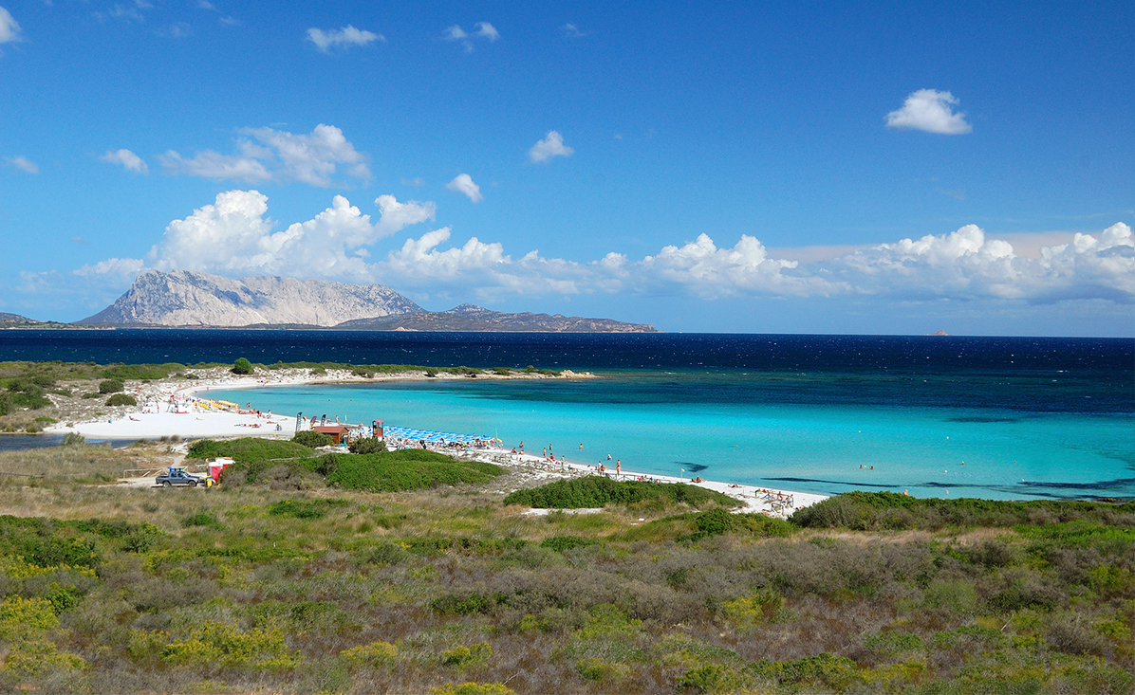

Isuledda Beach - San Teodoro

**Enjoy your holidays!**

Naujan Lake

LAKE, PHILIPPINES

WRITTEN BY:

* [The Editors of Encyclopædia Britannica](https://www.britannica.com/editor/The-Editors-of-Encyclopdia-Britannica/4419)

[See Article History](https://www.britannica.com/place/Naujan-Lake#accordion-article-history)

**Naujan Lake**, [lake](https://www.britannica.com/science/lake) on the northeastern coastal plain of [Mindoro](https://www.britannica.com/place/Mindoro), [Philippines](https://www.britannica.com/place/Philippines). It is the Philippines’ fifth largest lake, with an area of 30 square miles (79 square km). The lake is 8.5 miles (14 km) long and 4 miles (6 km) wide and is a productive freshwater fishing site. It is the central feature of Naujan Lake National Park (established in 1956), which [comprises](https://www.merriam-webster.com/dictionary/comprises) a 5,377-acre (2,175-hectare) area of marshes and forest that serve as breeding grounds for marsh birds, crocodiles, and sail-finned lizards. Naujan Lake was formerly a popular hunting and sport-fishing area; fishing rights have been retained only by neighbouring towns, for whom the lake is a source of livelihood.